--Day 7

--1.Rank employees by their total sales

--(Total sales = Total no of orders handled, JOIN employees and orders table)

Select emp.employee_id,

Count(ord.order_id) As total_sales,

Rank()Over(Order By Count(ord.order_id) Desc) As Sales_rank

From employees emp

Join orders ord

On emp.employee_id=ord.employee_id

Group By emp.employee_id

Order By total_sales Desc;

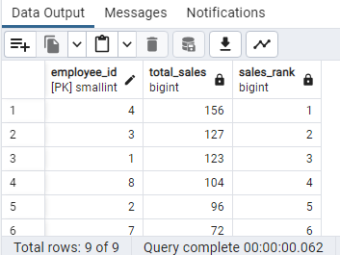

--2.Compare current order's freight with previous and next order for each customer.

--(Display order_id, customer_id, order_date, freight,

--Use lead(freight) and lag(freight).

Select customer_id,

order_id,

order_date,

freight,

Lag(freight) Over (Partition By customer_id Order By order_date) AS previous_freight,

Lead (freight)Over(Partition By customer_id Order By order_date)As next_freight

From public.orders

Order By 1,2;

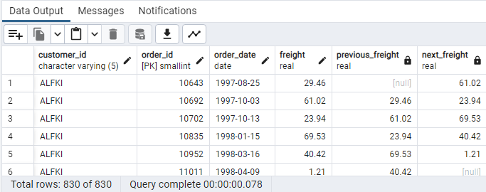

--3.Show products and their price categories, product count in each category, avg price:

--(HINT:

-- Create a CTE which should have price_category definition:

-- WHEN unit_price < 20 THEN 'Low Price'

-- WHEN unit_price < 50 THEN 'Medium Price'

-- ELSE 'High Price'

-- In the main query display: price_category, product_count in each price_category, ROUND(AVG(unit_price)::numeric, 2) as avg_price)

With price_category As

(Select product_id,

product_name,

unit_price,

Case

When unit_price < 20 THEN 'Low Price'

WHEN unit_price < 50 THEN 'Medium Price'

Else 'High Price'

End As price_category

From products)

Select

price_category,

Count(*) As product_count,

Round(Cast(Avg(unit_price) As numeric), 2) As avg_price

From price_category

Group By 1

Order By 1;

